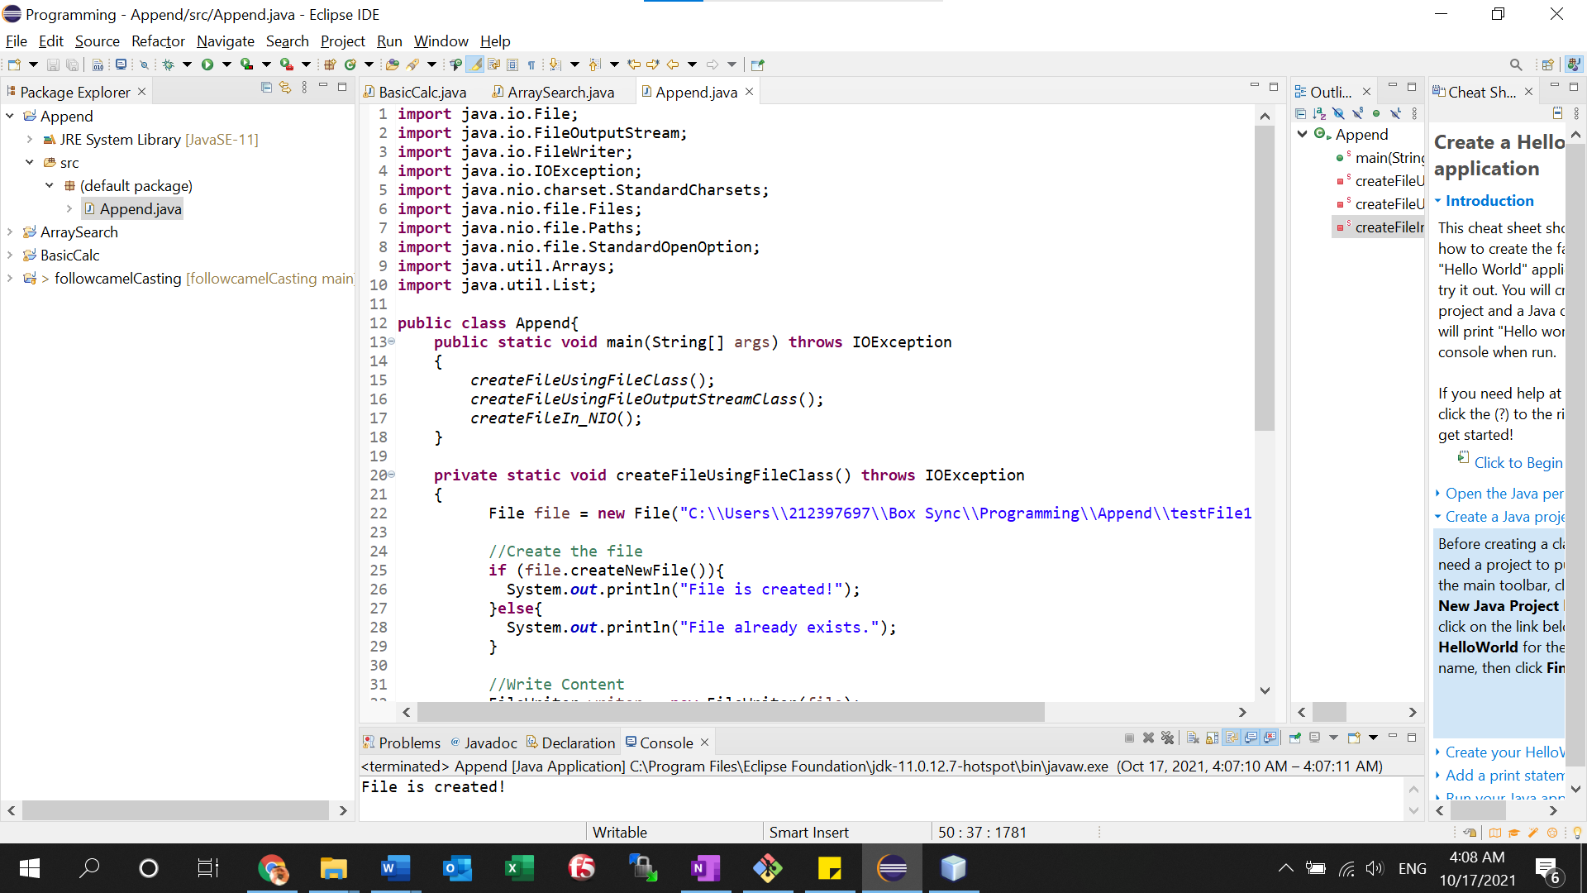

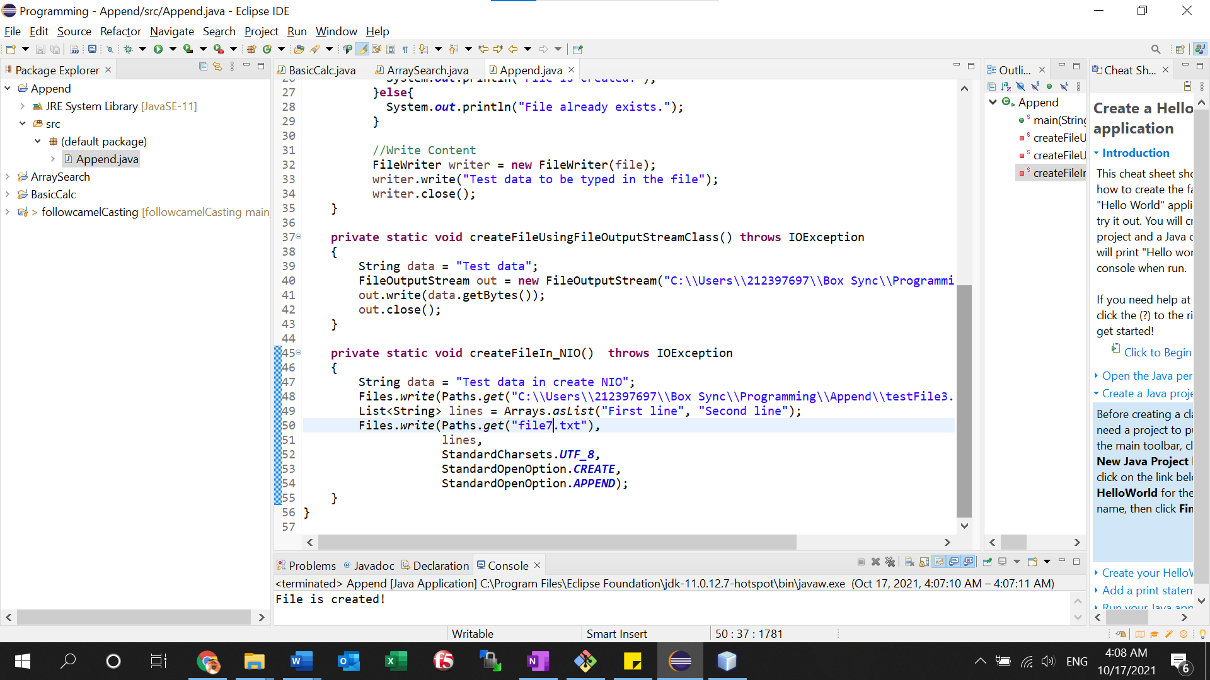

Source Code:

**import** java.io.File;

**import** java.io.FileOutputStream;

**import** java.io.FileWriter;

**import** java.io.IOException;

**import** java.nio.charset.StandardCharsets;

**import** java.nio.file.Files;

**import** java.nio.file.Paths;

**import** java.nio.file.StandardOpenOption;

**import** java.util.Arrays;

**import** java.util.List;

**public** **class** Append{

**public** **static** **void** main(String[] args) **throws** IOException

{

*createFileUsingFileClass*();

*createFileUsingFileOutputStreamClass*();

*createFileIn_NIO*();

}

**private** **static** **void** createFileUsingFileClass() **throws** IOException

{

File file = **new** File("C:\\Users\\212397697\\Box Sync\\Programming\\Append\\testFile1.txt");

//Create the file

**if** (file.createNewFile()){

System.***out***.println("File is created!");

}**else**{

System.***out***.println("File already exists.");

}

//Write Content

FileWriter writer = **new** FileWriter(file);

writer.write("Test data to be typed in the file");

writer.close();

}

**private** **static** **void** createFileUsingFileOutputStreamClass() **throws** IOException

{

String data = "Test data";

FileOutputStream out = **new** FileOutputStream("C:\\Users\\212397697\\Box Sync\\Programming\\Append\\testFile2.txt");

out.write(data.getBytes());

out.close();

}

**private** **static** **void** createFileIn_NIO() **throws** IOException

{

String data = "Test data in create NIO";

Files.*write*(Paths.*get*("C:\\Users\\212397697\\Box Sync\\Programming\\Append\\testFile3.txt"), data.getBytes());

List<String> lines = Arrays.*asList*("First line", "Second line");

Files.*write*(Paths.*get*("file7.txt"),

lines,

StandardCharsets.***UTF_8***,

StandardOpenOption.***CREATE***,

StandardOpenOption.***APPEND***);

}

}